Name | JOHN EDWARD ADAMS
Birth | 1890 Lanchester, Durham
Enlistment/Occupation | Hexham, Northumberland / Apprentice Grocer
Death, date, location | 26/04/1915  Died  France & Flanders  Recorded as one of 98 men missing from his battalion at St Julien on 26/04/1915 during the 2nd battle of Ypres.
Age | 25
Unit, rank, service no: | 1756  Private  1/4th Battalion (Territorials)  2nd/4th Batt Northumberland Fusiliers  Sent to France 20/04/1915(Medal rolls)
Photograph supplied by Judith Downes, Great niece | 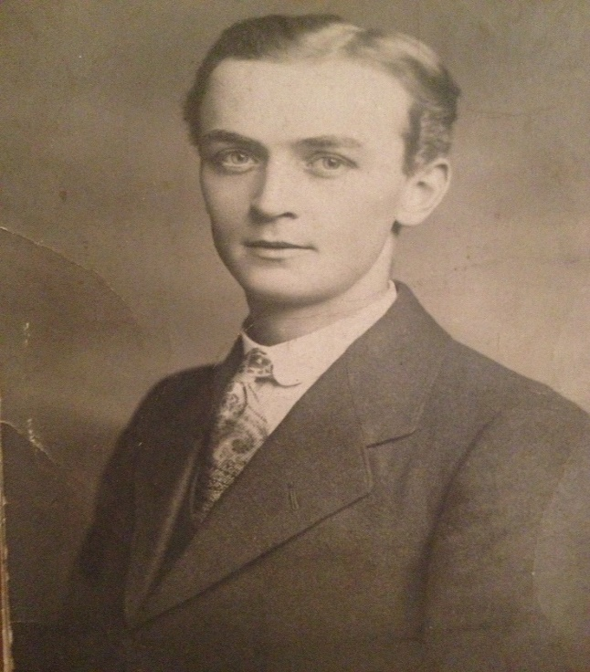
Family Acknowledgement CWGC | John Edward was the eldest son of John and Mary Ann Adams, of The Points, Hagg Bank, Wylam, Northumberland. (CWGC)
Family | John Edward Adams was born in Lanchester, County Durham in 1890 the second child of John and Mary Ann Adams (nee Todd) of New Hartley/Netherton who married in 1886 and had a two year old daughter Barbara born in 1888.  As father John was a railway signalman for the NER the family occupied a company house, and they had moved from Blyth to Lanchester and then in 1894 to Wylam into one of the four newly built NER houses overlooking the railway at Hagg Bank.  At the 1911 census the family at home comprised, the parents, John Edward 20, who was an apprentice in the Coop Grocery Dept:, Mary Ann 16, William 14, Elizabeth 12 at school, Alice 6 at school, and Barbara Foggan 15 (niece). Sadly, later in 1911 William died (aged 14) (circumstances not traced).  As far as we know John Edward continued his employment in the grocery trade during the period prior to the outbreak of war and although we do not have a date for his enlistment into the 1/4th Territorial Battalion of the Northumberland Fusiliers at Hexham he was amongst the earliest to enrol during 1914.  He was with the Battalion who were transported to Folkstone on 18/20 April 1915 and then across the Channel to Boulogne. Within less than a week of his arrival in France John Edward Adams became a casualty of the war recorded as one of almost a hundred men missing from his Battalion after the action at St. Julien on 26th April during the 2nd Battle of Ypres.  He was the first fatality of all those recorded men named on the Wylam War Memorials.  Among John Edward’s sisters, one, Mary Ann Adams subsequently trained as a teacher and taught at Wylam School for many years.
Photograph Of John Edward and girl friend Maggie. Supplied by Judith Downes, great niece. | 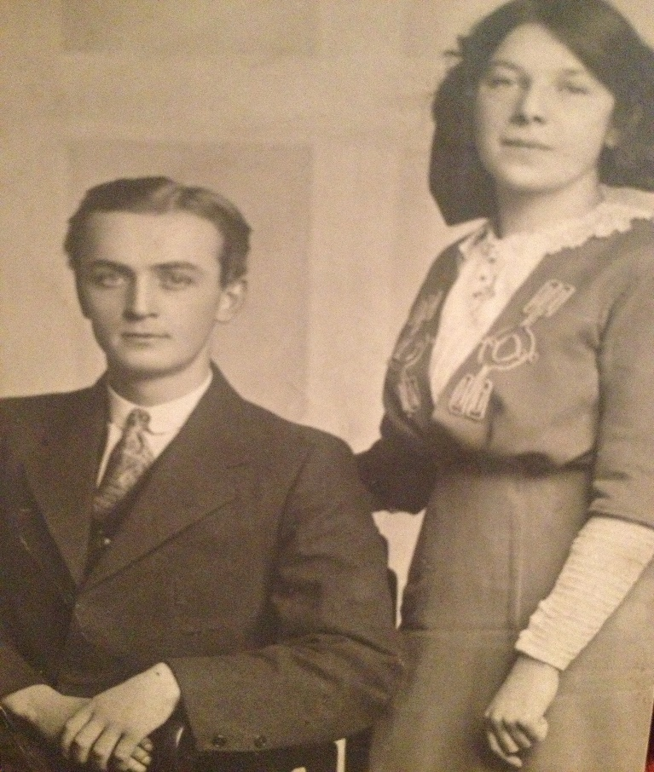
Battalion War Diary  1/4th Bn. Northumberland Fusiliers | The War Diary records that the battalion was mobilised on 4th August 1914 and on the 5th August all the officers and 657 other ranks reported. Training is recorded as taking place during August in N. Shields, Earsdon, Heaton and Gosforth Park. November records show the battalion billeted in Newcastle before being moved off to Blyth on 16th November 1914.  The War Diary omits any further records until April 1915. On 18th/20th April the Battalion was transported to Folkstone and then onto Boulogne, France. On 21st April trains took the battalion to Cassel where they were billeted on farms near the station. On 22nd April the battalion marched to billets in Oudezeele where orders were received to leave at 3.00pm the next day. Heavy firing was heard.  The War Diary for the period leading up to and including the date of John Edward Adams fatality continues as follows :-  23rd April ordered at 7.30am to move at once. Marched at 9.40 to Brgde HQ at Winniezeele. Arrived 10.20 moved 1.00pm via Doglandt, Watow, Poperinghe to Brandhoek about 14.5 miles. Very dusty. No men fell out. Took up position in dark  24th April 5.30pm order to move. Marched 6.00 thro’ Vlamertinghe & Ypres where we were halted for one hour under shell fire in the market square. Someone in front had lost direction in the town. 3 horses and 2 men wounded.  25th April to Potijze where Bn lay in a field in artillery formation for 1.5 hours about 30 shells fell into the field. One man wounded, Lt. Scaife lost speech thro’ concussion. Thence to Wieltje. Supported an attack by 10th Brigade. Half of 4th N.F. went further forward than intended and returned after dark to Wieltje. Killed 1 O.R., wounded Capt. D.H. Weir. Lt C.M. Joicey 2nd Lt W. Robinson. O.R. 33, missing O.R. 20 most of whom reported next day.  26th April Attack by Lahore Div. and Canadian Brgde, North’d Brigade at 1.40pm ordered to attack St. Julien at 2.5pm. Very heavy shell and M.G. fire. Reached our first line and a bit beyond in places. Retired after dark as the line was too crowded. Our Bn was drawn by fire to our left.  Captain Chipper when lying wounded in ditch on St.Julien road saw two men in Service Dress firing a M.G. from the dressing station outbuildings at our troops. When being carried back he was fired at by these men. Lt. Bunbury also states that he was fired on from the same place. When he advanced to it with his platoon he was waved on by some hospital orderlies who were also seen by Major Gibson. Captain G.L. Hunting also states that he was fired on from the same place.  Killed O.R.19.  Wounded Capts C. Chipper, L.D. Plumner, G.L. Hunting, J.W. Bunbury, H.E. Speke, H.M. Carrich  Wounded O.R.188  Missing O.R. 98  (OR=Other Ranks)  Mentioned* 2nd Lt. D.T. Turner  No.32 Sgt. J. W. Smith  No.1592 L.Cpl. E. Woodman Killed  No.1640 Pte. A. Brown  No.1517 Pte. G. Chadderton, DCM  27th April In 2nd line trenches. Burying parties.  *(Not clear meaning of ‘Mentioned’?)
Battalion | The 1/4th Battalion, Northumberland Fusiliers, a territorial battalion that recruited widely throughout the Tynedale area and was based in Hexham when war broke out in August 1914. After training they proceeded to France in April 1915, to join the 149th Brigade, 50th (Northumbrian) Division. They took part in the Second Battles of Ypres in 1915 and the Battle of the Somme in 1916, the Arras Offensive where they captured Wancourt Ridge and The Second Battle of Passchendaele in 1917. In 1918 they again saw action on The Somme and Battles of the Lys and Hindenburg Line.
War Memorials | Panel 8 and 12.  YPRES (MENIN GATE) MEMORIAL  Also commemorated in:-  School War Memorial Plaque, Falcon Centre Wylam  War memorial Plaque St.Oswin’s church, Wylam  War Memorial Monument, Wylam
Comments | On Military Service records John is incorrectly given as born in Lancaster, Lancs instead of in Lanchester, Co. Durham.  The 2nd Battle of Ypres April 1915 involved the first use of gas by either side in World War I when the Germans released chlorine gas into the allied lines. There is no mention of the use of gas by the Germans in the War Diary. The use of gas might also explain why John Edward is recorded as having ‘died’ rather than killed in action or died of wounds. Maybe he died as a result of gas inhalation?  The fact that John Edward’s name is commemorated on the Menin Gate memorial may also be significant as this memorial commemorates the names of 54,000 soldiers who died in the battles of Ypres, but for whom there is no known grave.
Sources | Commonwealth War Graves Commission  1891/1901/1911 Census  UK Soldiers died in Great War 1914-1919  War Diary 1/4th Bn Northumberland Fusiliers, Fusiliers Museum of Northumberland.

